W-17

12 PHYSICS ATAR

TEST 1 - PROJECTILE MOTION

NAME: MARK: 

When calculating numerical answers, show your working or reasoning clearly. Give final answers to **three** significant figures and include appropriate units where applicable.

1. A person on the tray of a truck travelling at 40.0 kmh–1 in a straight line throws a ball straight up at 8.00 ms–1 and catches it again at the same height. What horizontal displacement does the ball undergo whilst in flight? [4 marks]

2. A cannon fires a cannon ball horizontally at speed of 50.0 ms–1 from the top of a bridge that is 1.00 x 102 m above the surface of a lake below. Ignoring air resistance, calculate the velocity of the cannon ball just before it hits the water. [5 marks]

3. A cricket ball (hit from near the ground) strikes the ground just over the boundary

110 m from the batsman. A spectator estimates that the ball rose to a maximum height of

25 m. Use calculations to ***estimate*** the velocity with which the ball left the bat. [6 marks]



4. An arrow is fired at 30.0° above the horizontal with a speed of 90.0 ms–1. Neglect air resistance and consider the arrow to be a point mass.

(a) (i) At what instant in time after firing will the arrow be travelling the ***slowest***?

[2 marks]

(ii) What is the velocity of the arrow at this instant of time? [2 marks]

(b) Even though the target is at the same level as the bow when the arrow is released, the arrow is not fired directly along the line of sight (the **blue line** in the figure below).

Briefly, explain the reason for this. [3 marks]

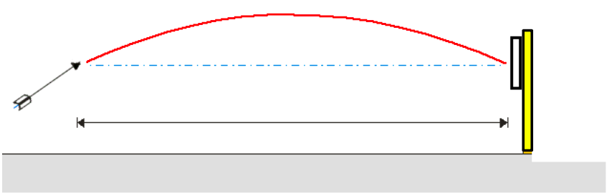

(c) At what different angle could the arrow be fired to achieve the same range? Show the trajectory on the diagram above. [2 marks]

5. On February 6 1971, during the Apollo 14 mission, astronaut Alan Shepard hit a golf ball on the Moon. The golf club launched the ball at an angle of 24.0° to the ground with an initial speed of 45.0 ms–1.

(a) Construct a labelled free body diagram below, showing the force(s) acting on the golf ball about halfway between it being struck and its highest point. [2 marks]



(b) Calculate the horizontal and vertical components of the initial velocity. [2 marks]

Answer uh …………………ms-1

Answer uv …………………ms-1

(c) Assuming the golf ball travelled over a level surface, a horizontal distance of

9.00 x 102 m, calculate:

(i) time taken to hit the surface. [2 marks]

(ii) the value of the acceleration due to gravity on the Moon. [4 marks]

6. An explosion in a tall building projects window glass outward ***and downward*** at 40.0 ms–1 at an angle of 20.0° below the horizontal. If the glass strikes the ground 4.50 s later:

(a) how far from the ground was the room in which the explosion occurred? [3 marks]

(b) how far from the base of the building does the glass land? [3 marks]

7. In a football game, a place kicker kicks a football from the ground at a distance of 36.0 m from the goalposts, and the ball must clear the crossbar, which is 3.10 m from the ground as shown in the diagram.

When kicked, the ball leaves the foot at 20.0 ms-1 at an angle of 53.0° to the horizontal.

(a) How long does the ball take to travel the distance to the goalposts? [3 marks]

(b) How far above or below the crossbar is the ball when it passes through the goal posts? [4 marks]

(c) Show on a sketch the path of the football. Include the goalposts in your sketch. Explain why you have drawn the path this way, ***showing any necessary working***.

***Label this path P***. [5 marks]

(d) On the sketch in (c) above, sketch the path of the football would take if air resistance was not negligible.

***Label this path A***. [2 marks]

(e) On the sketch in (c) above, sketch the path of the football would take if a tail-wind was present and the air resistance was negligible.

***Label this path W***. [2 marks]